Dear Bishop

Root & Branch Inclusive Synod, in Bristol and on Zoom, 5-12 September 2021.

I am a parishioner at ……………………..

I am writing to you in connection with an organisation called Root & Branch. This is a movement of committed Catholics who share the desire of us all for a strong, united Catholic Church that resonates and provides clear moral teaching for the 21st Century. Many of our children who were brought up as Catholics have disassociated themselves from the Church because the messages the Church is delivering jar with their vision of a modern and inclusive Church. I want to see a Catholic Church that can give hope and comfort to future generations in the same way that it has supported many of us in the past.
Root & Branch is organising a lay-led, inclusive Synod which will take place on Zoom and in person in Bristol in September 2021.

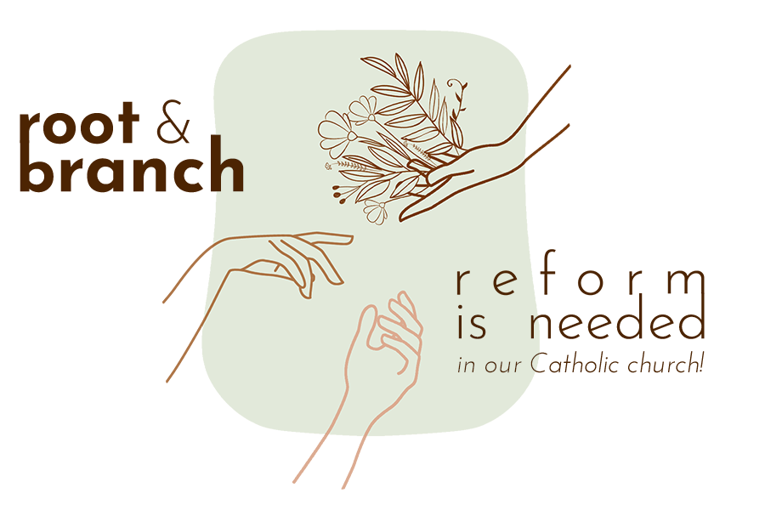
The Synod is special because ALL topics of concern to ordinary Catholics have already been and will continue to be open for discussion. It is our hope that a consensus will emerge and be recorded in what will be called The Bristol Text. The following aspects of Catholicism, which emerged after a journey of discernment with online speakers beginning last October, are currently being debated in breakout groups.

1 Redefining and reclaiming of ministry
2 Embracing diversity
3 Rethinking moral theology
4 Insisting on sharing authority

Statements and actions relating to these aspects will then go to expert panels for their contribution. It is hoped that this Text will become a key reference document which will support and encourage all Catholics participating in the Diocesan phase of Pope Francis’s Synod on Synodality which, as you know, starts in October 2021.

I fully appreciate that there are many equally committed Catholics who do not share my views on many of the ways forward for the Church. I know that, nevertheless, we all share a deep love for the Church and a desire for it to recover its place as a beacon of light and hope for our children and the generations ahead. In the spirit of synodality, these voices are equally valid, and I would equally urge them to participate.

So, the purpose of this message is to seek your support for the Synod by putting a briefing note about it on the Diocesan website, perhaps along the lines of the note on the website of the Clifton Diocese https://cliftondiocese.com/news/root-and-branch-inclusive-synod-from-5-12-september-2021/ and also to encourage the priests in the Diocese to raise awareness about the Root and Branch Synod through their Parish Newsletters.
Thank you for your time in considering this request, which I have kept brief. I would however very much welcome the opportunity of meeting with you to discuss the Synod in greater detail.

Yours in Christ

www.rootandbranchsynod.org
hello@rootandbranchsynod.org
+44 7968 390420

