ROOT & BRANCH Presentation to Congregations

Thank you for giving me the opportunity to make this address.

Perhaps you are aware of an organisation called Root & Branch. Root & Branch is a movement of committed Catholics who share the desire of us all for a strong, united Catholic Church that resonates and provides clear moral teaching for the 21st Century. Many of our children who were brought up as Catholics have disassociated themselves from the Church as it appears that the messages that the Church is delivering jar with their vision of a modern and inclusive Church. I want to see a Catholic Church that can give hope and comfort to future generations in the same way that it has supported many of us in the past.
Root & Branch is organising a lay-led inclusive Synod which will take place both on Zoom and in person in Bristol in September this year. The synod is special because ALL topics of concern to ordinary Catholics will be open for discussion in the hope that a consensus will emerge and be recorded in what will be called The Bristol Text. It is hoped that this Text will become a key reference document and will support and encourage all Catholics participating in the Diocesan phase of Pope Francis’s Synod on Synodality which starts in October 2021.

The keynote speaker at the Synod is Mary McAleese, former President of Ireland, and she is supported by an impressive array of speakers.

The following aspects of Catholicism, which emerged after a journey of discernment with online speakers beginning last October, have been debated in online Root & Branch gatherings:

1 Redefining and reclaiming of ministry
2 Embracing diversity
3 Rethinking moral theology
4 Insisting on sharing authority

Statements and actions relating to these aspects have now gone to expert panels for their contribution. It is hoped that this Text will become a key reference document which will support and encourage all Catholics participating in the Diocesan phase of Pope Francis’s Synod on Synodality which, as you know, starts in October 2021.

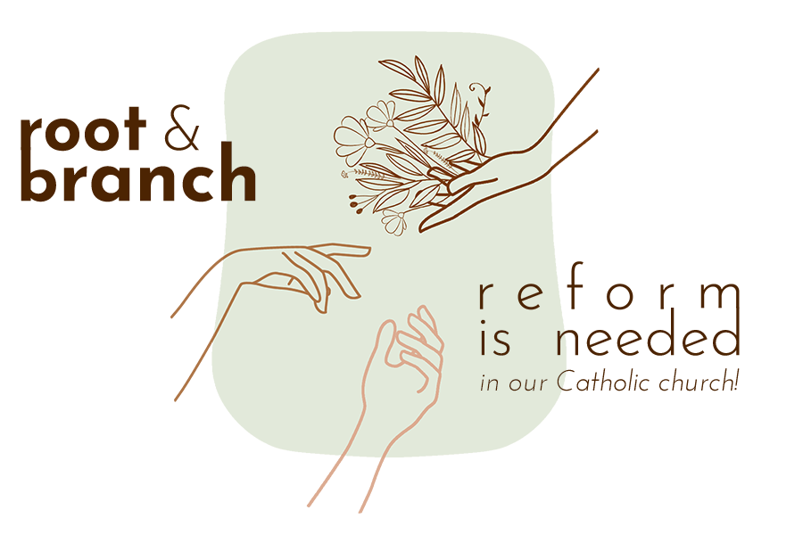
Clearly, this is a radical agenda and there will be a wide spectrum of opinions. It is very much hoped that, through listening and discussing, a consensus will emerge, and the concluding Bristol Text will contribute to the success of the Pope’s Synodal path.
I will be handing out flyers for the Synod at the end of Mass, but a lot of what you might want to know can be found on the Root & Branch Synod website.
To close, thank you for listening to me, particularly those among you who may not share my views on the way forward for the Church. I know that nevertheless, we all share a deep love for the Church and a desire for it to recover its place as a beacon of light and hope for our children and the generations ahead. In the spirit of synodality, your voices are equally valid, and I would urge you to participate.

www.rootandbranchsynod.org
hello@rootandbranchsynod.org
+44 7968 390420

